**Assignment 1.2**

**1. What should be the output of the following Script?**

**v <- c( 2,5.5,6)**

**t <- c(8, 3, 4)**

**print(v%/%t)**

**Output:-**

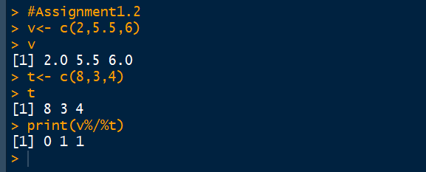

**2. You have 25 excel files with names as xx_1.xlsx, xx_2.xlsx,........xx_25.xlsx in a dir.**

**Write a program to extract the contents of each excel sheet and make it one df.**

**Answer :-**

setwd("C:/Users/krishna/Desktop/assignment1.2/New folder")

files=list.files(pattern=".xlsx")

for(i in 1:length(files))

{

filename=files[i]

data=read.delim(file = filename,header = T)

assign(x = filename,value = data)

}

#Suppose the columns are the same for each file,

#you can bind them together in one dataframe with bind_rows from dplyr:

library(dplyr)

df <- bind_rows(files, .id = "id")

#one more option is as follows

setwddf<-lapply(files, read.delim)%>% bind_rows()

View(setwddf)

**3. If the above 25 files were csv files, what would be your script to read?**

**Answer:**

setwd("C:/Users/krishna/Desktop/assignment1.2/New folder")

files=list.files(pattern=".csv")

for(i in 1:length(files))

{ filename=files[i]

data=read.csv(file = filename,header = T)

assign(x = filename,value = data)

}

#Suppose the columns are the same for each file,

#you can bind them together in one dataframe with bind_rows from dplyr:

library(dplyr)

df <- bind_rows(files, .id = "id")

#one more option is as follows

df<-lapply(files, read.csv) %>% bind_rows()

setwddf<-lapply(files, read.csv)%>% bind_rows()

View(setwddf)